# How to create a photo album (SSB News site)

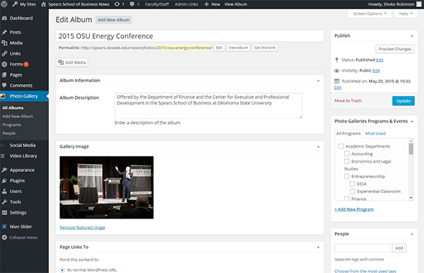

1. Select ‘Photo Gallery’ – ‘Add New Album’.
2. Enter the title and the album description, set the featured image, and select appropriate categories for the photo album.
3. Click ‘Add Media’ to upload photos. There is no strict rule about photo quality/size, but 800 pixels width/hight is good enough.

Featured image

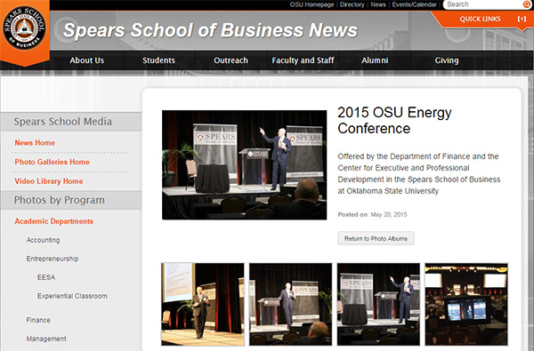

Media  
To change order of photos, refer ‘How to change order of photos’

Album description

Categories

Title

1. Update.