Login to the Spears School Website at <http://spears.okstate.edu/wp-admin> using your Full O-Key Email Address (short okey names will not work here) and O-Key Password  
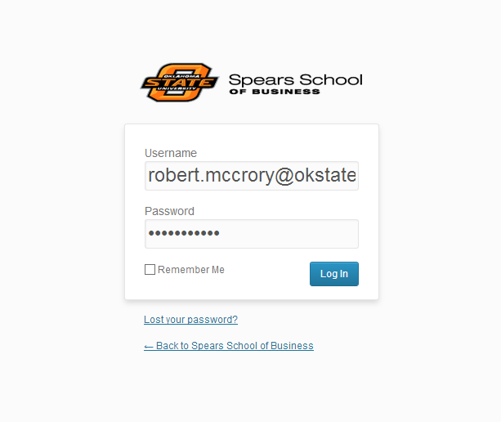

Once you are logged in, hover over the text that says ‘Howdy, Your Name’ in the top right hand corner. A drop down menu will appear. Click on ‘Edit My Profile’.

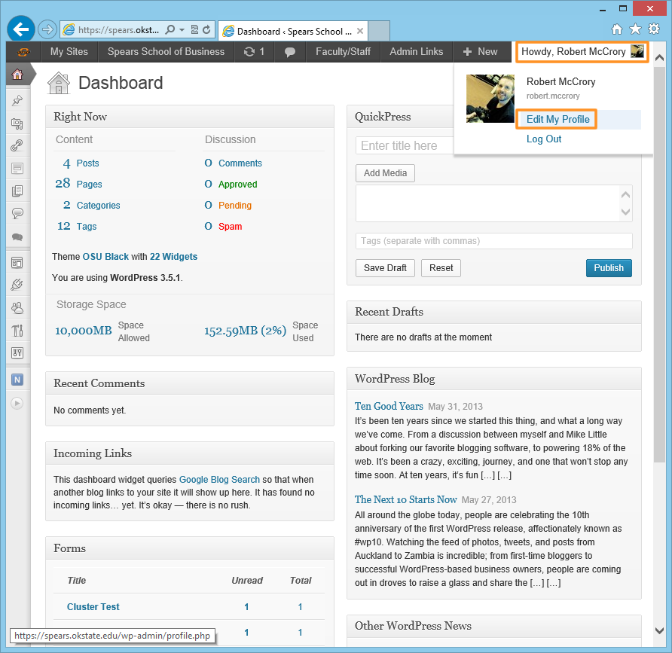

The ‘Profile’ screen will appear. Scroll down this screen until you reach the ‘About Yourself’ section. In this section there is a new textarea field titled ‘Research Summary’. Use this field to enter a description of your research (see <http://spears.okstate.edu/management/research> for examples). If you are copying and pasting this text from a Word Document, be sure to use the ‘Paste from Word’ tool to remove the word formatting as it doesn’t play nice with the web.

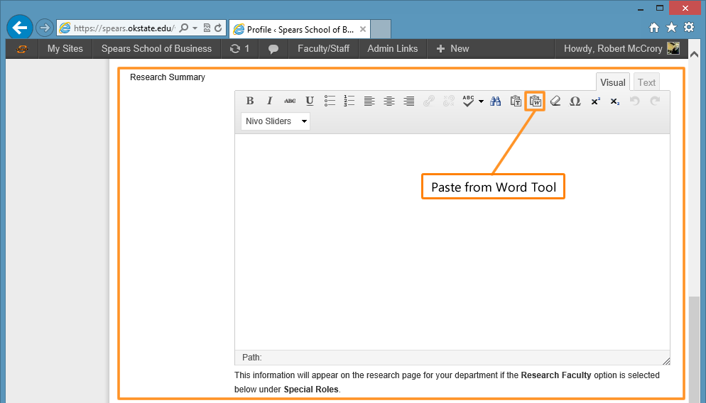

Once you have finished adding your research information you need to check a box that will make you appear on your department’s Research page. To do this, scroll down a little further until you reach a section titled ‘Special Roles’. In this section place a checkmark next to ‘Research Faculty’. Finally, click on ‘Update Profile’. Your Research Summary will now appear on your department’s research page.

